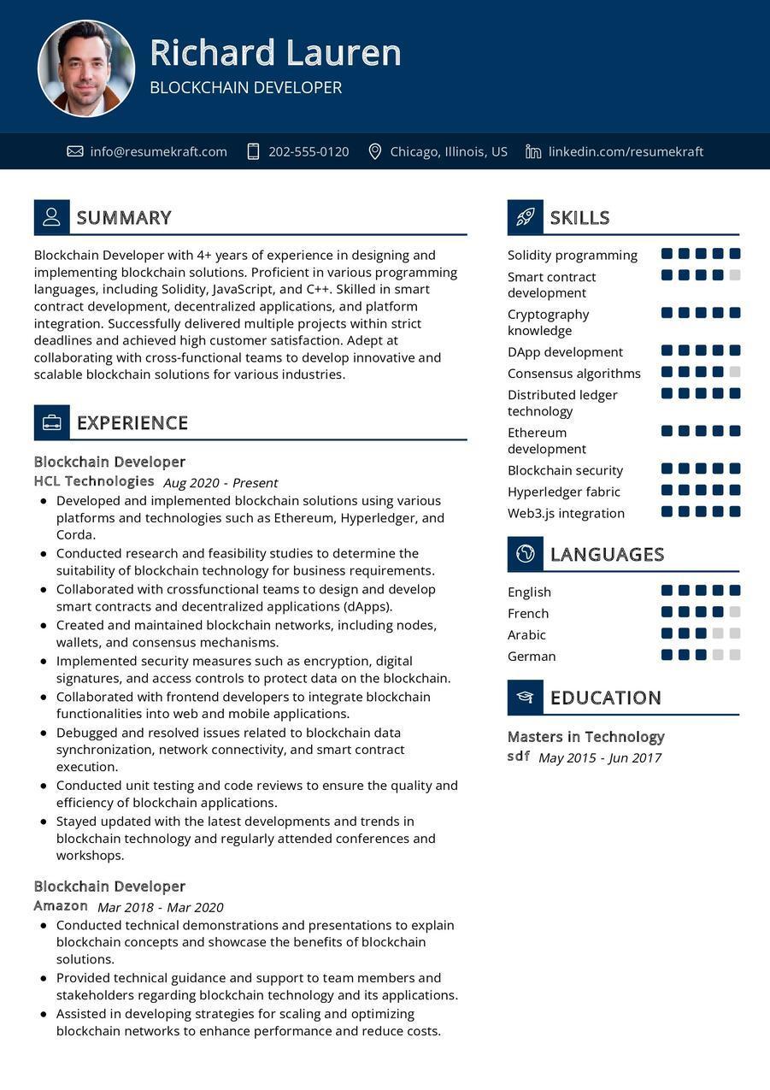
Richard Lauren
BLOCKCHAIN DEVELOPER
info@resumekraft.com
202-555-0120
Chicago, Illinois, US in linkedin.com/resumekraft
2 SUMMARY
Blockchain Developer with 4+ years of experience in designing and implementing blockchain solutions. Proficient in various programming languages, including Solidity, JavaScript, and C++. Skilled in smart contract development, decentralized applications, and platform integration. Successfully delivered multiple projects within strict deadlines and achieved high customer satisfaction. Adept at collaborating with cross-functional teams to develop innovative and scalable blockchain solutions for various industries.
SKILLS
Solidity programming
Smart contract development Cryptography knowledge
DApp development Consensus algorithms Distributed ledger
technology
Ethereum
EXPERIENCE
Blockchain Developer
HCL Technologies Aug 2020 - Present
• Developed and implemented blockchain solutions using various platforms and technologies such as Ethereum, Hyperledger, and Corda.
• Conducted research and feasibility studies to determine the suitability of blockchain technology for business requirements. • Collaborated with crossfunctional teams to design and develop smart contracts and decentralized applications (dApps). • Created and maintained blockchain networks, including nodes, wallets, and consensus mechanisms.
• Implemented security measures such as encryption, digital signatures, and access controls to protect data on the blockchain.
• Collaborated with frontend developers to integrate blockchain functionalities into web and mobile applications.
• Debugged and resolved issues related to blockchain data synchronization, network connectivity, and smart contract execution.
• Conducted unit testing and code reviews to ensure the quality and efficiency of blockchain applications.
• Stayed updated with the latest developments and trends in blockchain technology and regularly attended conferences and workshops.
Blockchain Developer
Amazon Mar 2018 - Mar 2020
• Conducted technical demonstrations and presentations to explain blockchain concepts and showcase the benefits of blockchain solutions.
• Provided technical guidance and support to team members and stakeholders regarding blockchain technology and its applications. • Assisted in developing strategies for scaling and optimizing blockchain networks to enhance performance and reduce costs.
development
Blockchain security
Hyperledger fabric
Web3.js integration
English
French
Arabic
LANGUAGES
German
EDUCATION
Masters in Technology
sdf May 2015-Jun 2017

